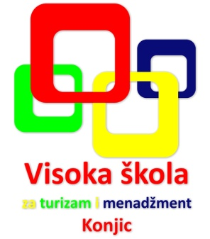
Visoka škola za turizam i menadžment
Varda 1, Društveni dom
88 400 Konjic, Bosna i Hercegovina
Tel.: +387 36 727 330
Fax: +387 36 727 330
info@vstim-konjic.ba
www.vstim-konjic.ba

Scientific Conference with International Participation
"Religious Tourism and Theology"
September 25 - 26, 2019
Gazi Husrev-bey's Library, Sarajevo, Bosnia and Herzegovina

REGISTRATION FORM
(Please use block letters)

SURNAME:

NAME:

ACADEMIC TITLE:

ADDRESS:

PHONE NUMBER:

E-MAIL:

INSTITUTION:

Please send your application form and abstract not later than July 10, 2019.

For any additional information, please visit www.vstim-konjic.ba or contact us by e-mail:

konferencija.vstim@gmail.com and alaudina.vstim@gmail.com.

